Software Requirements Specification
Version 2.0

Grocery Store Inventory Management System

Team #7
Member Name | Member Roll #
Oneeb | 15L-4350
Syed Usama bin Jawad | 15L-4137
Ali Nuaman | 15L-4264
Ahmad Bilal | 15L-4243
Abu Bakar Sohail | 15L-4155

Contents
1. Introduction 1
1.1 Product 1
1.2 Scope 1
1.3 Business Goals 1
1.4 Document Conventions 1
1.5 References 1
2. Overall Description 3
2.1 Product Features 3
2.2 User Classes and Characteristics 3
2.2.1 General Manager 3
2.2.2 Branch Manager 3
2.2.3 Salesman 4
2.3 Operating Environment 4
2.4 Design and Implementation Constraints 4
2.5 Assumptions and Dependencies 5
3. Functional Requirements 6
3.1 Login 6
3.2 Add branch 6
3.3 Remove branch 7
3.4 Set branch manager 8
3.5 Add salesman 9
3.6 Remove salesman 10
3.7 Request stock 11
3.8 Handle stock request 11
3.9 Sell grocery item to customer 12
3.10 Search grocery item 13
3.11 View inventory 14
3.12 View statistical report of branch 14
3.13 Remove branch manager 15
4. Nonfunctional Requirements 17
4.1 Performance Requirements 17
4.2 Security Requirements 17
5. Other Requirements 18
6. Appendix A: Glossary 19
7. Appendix B: Analysis Models 20
7.1 Use-case Diagram 20
7.2 ER Diagram 21
7.3 UML Class Diagram 22
7.4 Dataflow Diagram (Level 0) 23
8. Appendix C: Design Models 24
8.1 Component Model 24

Revision History

Names | Date | Reason(s) For Change(s) | Version
Initial version | October 15, 2018 | Introduction, functional requirements, non-functional requirements, other requirements, and appendix A and B complete | 1.0
First iteration | November 19, 2018 | Overall description of product added, typos and formatting issues fixed, glossary updated, appendix C added, notes from first deliverable applied | 2.0

Introduction

Product
We are developing an inventory management system for a chain of grocery stores. This software will be responsible for setting up various branches of the store, which includes adding details about the staff, and keeping track of inventory state and sales. This system will offer a more streamlined and efficient approach through which general managers and branch managers will be able to manage their respective grocery stores.

Scope
The goal of this project is to allow general and branch managers of grocery stores to efficiently manage their workflow and store setup process. The core functionalities and deliverables of this inventory management system include:

- Ability to add branch managers
- Set up branch with necessary details
- Ability to add sales staff and grocery store branches
- Functionality to request stock from warehouse
- Ability to search for inventory items
- Capability to check the current state of the inventory

This system will be built in a generic way so that it can be used across various grocery store chains without extensive modification. Effort has been poured into making the system cost-effective, but reliable, efficient, and simple, so that it is flexible to the user’s needs.

Business Goals
The inventory management system meets various goals of corporations in this business including:
- Branch management
- Employee management
- Stock management
- Inventory management
- Digital platform rather than paper-based

Document Conventions
This document follows a uniform format in general text throughout, however, some important points have been added in bold for increased emphasis.

References
[1] | G. K. O. Michael and L. McCathie, "The pros and cons of RFID in supply chain management," IEEE, 15 August 2005. [Online]. Available: https://ieeexplore.ieee.org/abstract/document/1493672. [Accessed 15 October 2018].
[2] | R. Fielding, "RFC 7230," RFC Editor, June 2014. [Online]. Available: http://www.rfc-editor.org/info/rfc7230. [Accessed 15 October 2018].

Overall Description

Product Features
The Grocery Store Inventory Management System will primarily be used by the management staff of the respective grocery store. The salient features of the software include:

- Keeping a record of grocery items being sold to customers in real-time.
- Managing grocery stock in warehouse and in brick-and-mortar retail outlet.
- Assigning management staff to outlets.
- Automated report of the finances and progress of the grocery store.
- Managing various branches of the grocery store.

User Classes and Characteristics

General Manager
The General Manager is the user with the highest level of privilege and is responsible for managing the finances and stock of all the branches of their grocery store. However, the General Manager will primarily use the software only when required, i.e.: when they get a request for stock refill or when adding a new branch. As such, the technical expertise required for this user is low as they will rarely interact with the software.

Name | General Manager
Frequency of use | Low
Product functions used | - Managing grocery stock  - Generating automated report of finances of grocery store  - Managing various branches of grocery store
Technical expertise | Low
Privilege level | High

Branch Manager
The Branch Manager has a medium privilege level because they will not be able to view the data or manage other branches of the grocery store chain. This user will utilize the software more frequently than the General Manager, as they will be required to manage their branch’s low-level staff as well as monitor stock. The technical expertise of this user will be medium – which is higher than the General Manager – because they will be required to use the software on a more frequent basis than the General Manager.

Name | Branch Manager
Frequency of use | Medium
Product functions used | - Monitoring grocery stock  - Managing staff at branch
Technical expertise | Medium
Privilege level | Medium

Salesman
The salesman is the lowest priority user since they will only be responsible for selling grocery store items to customers rather than managing the staff, finances or the stock of the grocery store. However, they will utilize the system more frequently than the aforementioned users since they will deal with potentially hundreds of customers purchasing grocery items every day. As such, the technical expertise required for this user will be quite high based on their frequency of use.

Name | Salesman
Frequency of use | High
Product functions used | - Monitoring grocery stock in branch  - Selling grocery items to customers
Technical expertise | High
Privilege level | Low

Operating Environment
The software will be used on the computers available in grocery stores and in the offices of general managers and branch managers. On the hardware end, it requires RFID scanner - so users can log in to the system in a more secure manner - a barcode scanner and its accompanying software in order to efficiently add and remove grocery store items from the store using their respective barcodes. On the software end of the application, a computer running Windows 7 or higher is required, with 4GB of RAM, at least 10GB of storage space. It is recommended that a robust hardware system is used with the software, keeping in mind that it will be prone to damages because it is being used in an open environment on a regular basis.

Design and Implementation Constraints
The inventory store management system currently supports all RFID scanners offered by Impinj, Vulcan, and TURCK. Although RFID hardware offered by other companies is not supported as of yet, compatibility for them may be offered in future iterations of the software. Customers who purchase the inventory management store system will be offered 1TB of free cloud storage with the latest attribute-based encryption techniques and other security standards. This complimentary package will also support up to 1,000 parallel operations. Grocery stores which require more processing power can upgrade to our premium package, which supports unlimited cloud storage and parallel processing power for a yearly subscription fee.
Since the software is primarily a database management system, it will use the latest SQL standards and communication techniques to interact with the cloud database in a secure way. Although cloud storage is supported and recommended, in case of unreliable internet connection, copies of the latest changes in the database will also be stored on local machines, which is why 10GB of local storage space is required on systems operating the software. When a reliable data connection is established, the local changes will be automatically be made to the cloud database as well.

The software is available in English language by default, but support for more languages will be available on demand. Customers who purchase the software for the grocery store branch will not be required to maintain and ensure the quality of the software directly but will be offered five years of free on-site and off-site support.

Assumptions and Dependencies
- Internet will be available for cloud storage.
- In case internet is not available, local storage of at least 10GB is required on the machine operating the software.
- The software supports the latest versions of RFID scanners and software offered by Impinj, Vulcan, and TURCK. Updates to the RFID software offered by these companies will be backward-compatible with the grocery store inventory management system software.
- The users of the software will have the basic technical expertise required to run computer systems and software.

Functional Requirements

Login
Identifier |  | UC-1
Name |  | Login
Summary |  | A user logs in to the application.
Priority |  | High
Actors |  | General Manager, Branch Manager, Sales Man
Pre-condition(s) |  | None
Post-condition(s) |  | Actor’s home screen is displayed.
Typical Course of Action
S# | Actor Action |  | System Response
1 | Actor Selects “login” button.
2 |  |  | System redirects to “Login” page.
3 | Actor will enter the employee ID and password.
4 |  |  | System redirects to Actors designated home page.
Alternate Course of Action (Wrong Employee ID/Password)
S# | Actor Action |  | System Response
3 |  |  | System will give an error message.
Go To 3

Table: UC-1

Add branch
Identifier |  | UC-2
Name |  | Create Branch
Summary |  | General Manager will create a new grocery store branch.
Priority |  | High
Actors |  | General Manager
Pre-condition(s) |  | User is logged in.
Post-condition(s) |  | New Branch will be created.
Typical Course of Action
S# | Actor Action |  | System Response
1 | General Manager selects “Add New Branch” button.
2 |  |  | System will redirect to “Input Form” page.
3 | The General Manager will enter the details for the branch to be created.
4 |  |  | System will add new branch to database.
5 |  |  | System redirects back to General Managers home page.
Alternate Course of Action (Incorrect/Incomplete Information)
S# | Actor Action |  | System Response
3 |  |  | System Displays error message.
Go To 3

Table: UC-2

Remove branch

Identifier |  | UC-3
Name |  | Remove Branch
Summary |  | General Manager will remove a grocery store branch.
Priority |  | High
Actors |  | General Manager
Pre-condition(s) |  | User is logged in.
Post-condition(s) |  | A branch will be deleted.
Typical Course of Action
S# | Actor Action |  | System Response
1 | General Manager selects “Remove Branch” button.
2 |  |  | System will redirect to “Select Branch” page.
3 | The General Manager will select the branch to be removed from a list of available branches.
4 |  |  | System will remove the selected branch from its database.
5 |  |  | System redirects back to General Managers home page.
Alternate Course of Action (Manager Presses Go Back Button)
S# | Actor Action |  | System Response
2 |  |  | System redirects back to General Managers home page.

Table: UC-3

Set branch manager
Identifier |  | UC-4
Name |  | Set Branch Manager
Summary |  | General Manager will select a branch manager.
Priority |  | High
Actors |  | General Manager
Pre-condition(s) |  | User is logged in.
Post-condition(s) |  | Branch will have a branch manager.
Typical Course of Action
S# | Actor Action |  | System Response
1 | General Manager selects “Set Branch Manager” button.
2 |  |  | System will redirect to “Create Manager” page.
3 | The General Manager will enter the details for the branch manager to be created.
4 |  |  | System will create a branch manager.
5 |  |  | System will redirect to “Select Branch” page.
6 | The General Manager selects the branch to assign branch manager to.
7 |  |  | System will assign created branch manager to specified branch.
8 |  |  | System redirects back to General Manager’s home page.
Alternate Course of Action (Incorrect/Incomplete Info)
S# | Actor Action |  | System Response
3 |  |  | System Displays error message.
Go To 3
Alternate Course of Action (Branch already has a branch manager)
S# | Actor Action |  | System Response
6 |  |  | System displays prompt if branch manager is to be replaced.
7 | General Manager selects yes or no option.
8 |  |  | System updates or skips set branch manager according to General manager’s selection.
9 |  |  | System redirects back to General Manager’s home page.

Table: UC-4

Add salesman
Identifier |  | UC-5
Name |  | Add Salesman
Summary |  | Branch Manager adds a Salesman to his Branch.
Priority |  | Medium
Actors |  | Branch Manager
Pre-condition(s) |  | User is logged in.
Post-condition(s) |  | New Salesman is added.
Typical Course of Action
S# | Actor Action |  | System Response
1 | Branch Manager selects “Add new Salesman” button.
2 |  |  | System will redirect to “Salesman Info” Page.
3 | Branch Manager will enter details for salesman to be added.
4 |  |  | System will create a sales man.
5 |  |  | System adds salesman to branch.
6 |  |  | System redirects back to Branch Managers home page.
Alternate Course of Action (Incorrect/Incomplete Information)
S# | Actor Action |  | System Response
3 |  |  | System Displays error message.
Go To 3

Table: UC-5

Remove salesman
Identifier |  | UC-6
Name |  | Remove salesman
Summary |  | Branch Manager removes a Salesman from his Branch.
Priority |  | Medium
Actors |  | Branch Manager
Pre-condition(s) |  | User is logged in.
Post-condition(s) |  | A Salesman is removed.
Typical Course of Action
S# | Actor Action |  | System Response
1 | Branch Manager selects “Remove Sales Man” button.
2 |  |  | System will redirect to “Salesman ID” Page.
3 | Branch Manager will select the salesman to be removed from a list.
4 |  |  | System removes salesman from database.
5 |  |  | System redirects back to Branch Manager’s home page.
Table: UC-6

Request stock

Identifier |  | UC-7
Name |  | Request Stock
Summary |  | Branch Manager issues requests for additional grocery stock from warehouse.
Priority |  | High
Actors |  | Branch Manager
Pre-condition(s) |  | User is logged in.
Post-condition(s) |  | General Manger is displayed the request.
Typical Course of Action
S# | Actor Action |  | System Response
1 | Branch Manager selects “Request stock” button.
2 |  |  | System will redirect to “Stock Info” Page.
3 | Branch Manager will select the Stock item names and corresponding quantities from a list.
4 |  |  | System adds request to database.
5 |  |  | General manager gets a message to approve or reject request.
6 |  |  | System redirects back to Branch Managers home page.

Table: UC-7

Handle stock request
Identifier |  | UC-8
Name |  | Handle inventory stock request
Summary |  | General Manager will accept or reject a inventory stock request from a branch
Priority |  | High
Actors |  | General Manager
Pre-condition(s) |  | User is logged in and there is a stock request.
Post-condition(s) |  | Branch is granted or denied new stock of grocery items.
Typical Course of Action
S# | Actor Action |  | System Response
1 |  |  | System Displays “Inventory Stock Request” message on General Manager’s Home Page.
2 | General Manager Selects “Re-Inventory Request” message.
3 |  |  | System Displays the request details and redirects to “Handle Request” page.
4 | General Manager chooses “Accept”.
5 |  |  | System adds the required grocery items and quantities to the branch.
6 |  |  | System Displays “Request Accepted” message on Branch Manager’s Home Page.
7 |  |  | System redirects back to General Managers home page.
Alternate Course of Action (Manager Chooses Reject)
S# | Actor Action |  | System Response
6 |  |  | System Displays “Request Rejected” message on Branch Manager’s Home Page.
Go To 7

Table: UC-8

Sell grocery item to customer
Identifier |  | UC-9
Name |  | Sell grocery item to Customer
Summary |  | Salesman sells grocery item(s) to a customer.
Priority |  | High
Actors |  | Salesman
Pre-condition(s) |  | User is logged in.
Post-condition(s) |  | A sale is made.
Typical Course of Action
S# | Actor Action |  | System Response
1 | Salesman selects “Sell grocery” button.
2 |  |  | System redirects to “Sell Grocery” page.
3 | Salesman selects grocery items and their corresponding quantities from the grocery items that the customer has brought to the counter.
4 |  |  | System adds Sale to database.
5 |  |  | System Updates branch inventory.
6 |  |  | System redirects to Salesman homepage.

Table: UC-9

Search grocery item
Identifier |  | UC-10
Name |  | Search grocery item
Summary |  | Salesman searches for a grocery item in inventory
Priority |  | Medium
Actors |  | Salesman
Pre-condition(s) |  | User is logged in.
Post-condition(s)
Typical Course of Action
S# | Actor Action |  | System Response
1 | Sales Man selects “search grocery item” option.
2 |  |  | System redirects to “search” page
3 | Salesman inputs grocery item name
4 |  |  | System Displays the search result
5 | Salesman selects “home page” option
6 |  |  | System redirects to homepage
Alternate Course of Action (Grocery item does not exist)
S# | Actor Action |  | System Response
4 |  |  | System displays “Grocery item does not exist” message to Salesman.
Go To 6

Table: UC-10

View inventory

Identifier |  | UC-11
Name |  | View Inventory
Summary |  | Branch Manager views the current inventory of his branch.
Priority |  | Medium
Actors |  | Branch Manager
Pre-condition(s) |  | User is logged in.
Post-condition(s)
Typical Course of Action
S# | Actor Action |  | System Response
1 | Branch Manager selects “View Inventory” button.
2 |  |  | System displays the current inventory.
3 | Branch Manager Selects “Home Page” button.
4 |  |  | System Redirects to Home Page.

Table: UC-11

View statistical report of branch
Identifier |  | UC-12
Name |  | View Branch Report
Summary |  | General Manger views the report of sales of a selected branch
Priority |  | Medium
Actors |  | General Manager
Pre-condition(s) |  | User is logged in.
Post-condition(s)
Typical Course of Action
S# | Actor Action |  | System Response
1 | General Manager selects “View Branch Report” button.
2 |  |  | System Displays redirects to “Get Branch Report” page.
3 | General Manager enters code of Branch for which to view report.
4 |  |  | System Displays report of the selected branch.
5 | General Manager Selects “Home Page” button
6 |  |  | System Redirects to General Manager’s home page.
Alternate Course of Action (Incorrect Branch Code)
S# | Actor Action |  | System Response
3 |  |  | System Displays error message.
Go To 3

Table: UC-12

Remove branch manager
Identifier |  | UC-13
Name |  | Remove branch manager
Summary |  | General Manager removes a Branch Manager.
Priority |  | Medium
Actors |  | General Manager
Pre-condition(s) |  | User is logged in.
Post-condition(s) |  | A Branch Manager is removed.
Typical Course of Action
S# | Actor Action |  | System Response
1 | General Manager selects “Remove Branch Manager” button.
2 |  |  | System will redirect to “Branch Manager ID” Page.
3 | General Manager will select the Branch Manager to be removed from a list.
4 |  |  | System removes Branch Manager from database.
5 |  |  | System redirects back to General Manager’s home page.

Table: UC-13

Nonfunctional Requirements

Performance Requirements
- Synchronization: It is important that the system updates in real-time and is synchronized across all systems currently in use, especially when multiple salesman are accessing the inventory, or when branch managers are requesting stock, so that all users of the system can see the current state and do not over-request items or remove them without other users of the system being aware of them in real-time.
- Speed: It is essential that the system operates at an efficient but extremely fast speed, with grocery items being removed from the inventory in less than 0.5 seconds after scanning its bar code / ID so that the customer does not have to wait long in a queue before checking out.

Security Requirements
- Data backup: Data must be backed up daily so if any malicious activity takes place, it can be accurately detected.
- Trace: It is essential that any activity that takes place in the system on behalf of any user (General Manager, Branch Manager, Salesman) is recorded so any malicious activity can be tracked back to its perpetrator.
- HTTPS: It is important that a secure HTTPS [1] protocol is used to transmit data over the internet such as stock requests to the General Manager so that it cannot be tampered with.

Other Requirements
- Enhanced security: Although not necessary, an RFID scanner [1] can also be deployed on the system, which allows customers to scan their ID cards to be logged in.
- Barcode scanner and software: A fast barcode reader and accompanying software is required so that it can scan the barcode of grocery items, identify them correctly, and remove them from the inventory when the customer purchases them.
- Computers: Essentially all users of this inventory management system will be interacting with it using computers. These do not need to be specialized but they do need to have support for barcode readers and any such accompanying software.

Appendix A: Glossary
- HTTPS: Hypertext Transfer Protocol Secure (HTTPS) is an extension of Hypertext Transfer Protocol (HTTP) and is utilized for secure data transmission over the internet.
- RFID: Radio-frequency Identifiers (RFID) refers to digital data being embedded in smart tags which emit radio waves that can be interpreted by RFID readers. It is primarily used to enhance digital security.
- SQL: Structured Query Language, used to interact with SQL databases.

Appendix B: Analysis Models

Use-case Diagram
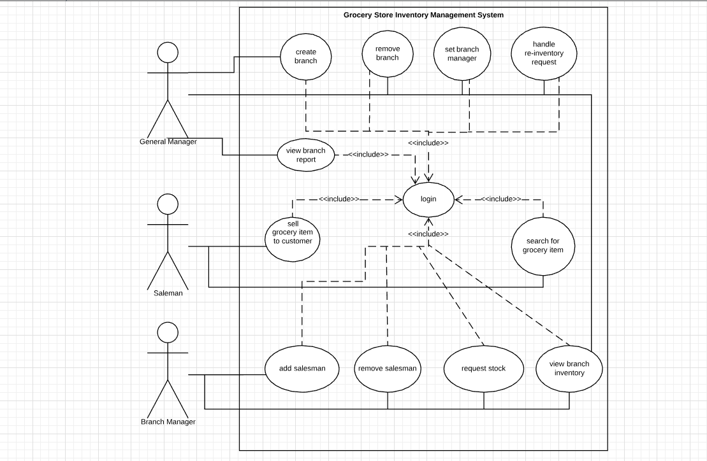

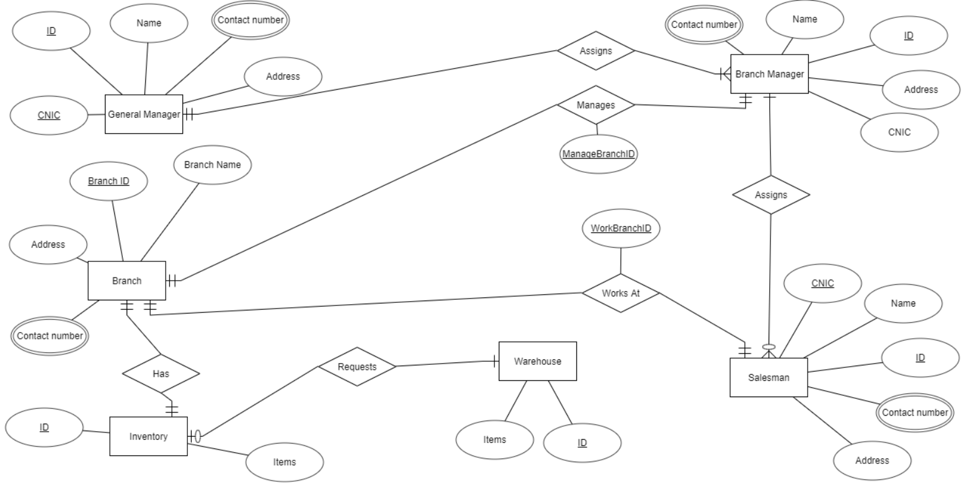
ER Diagram

UML Class Diagram

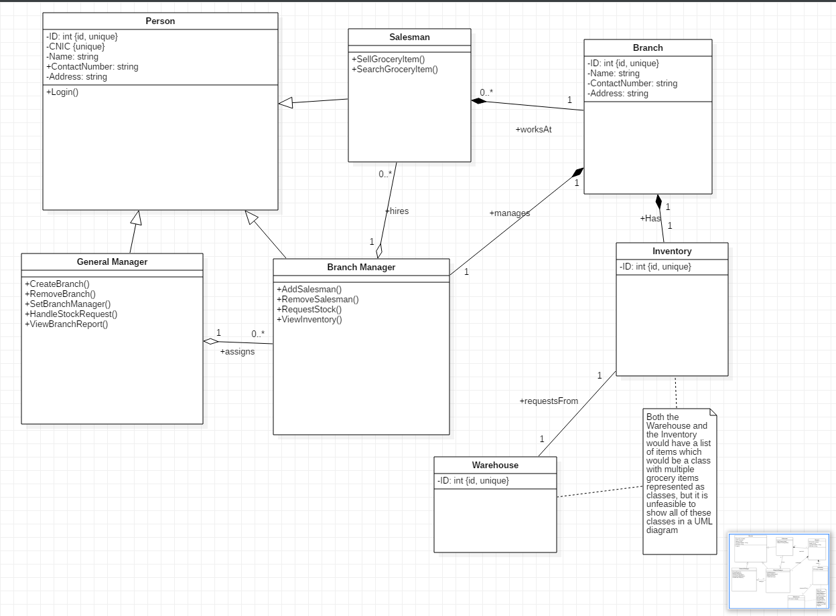

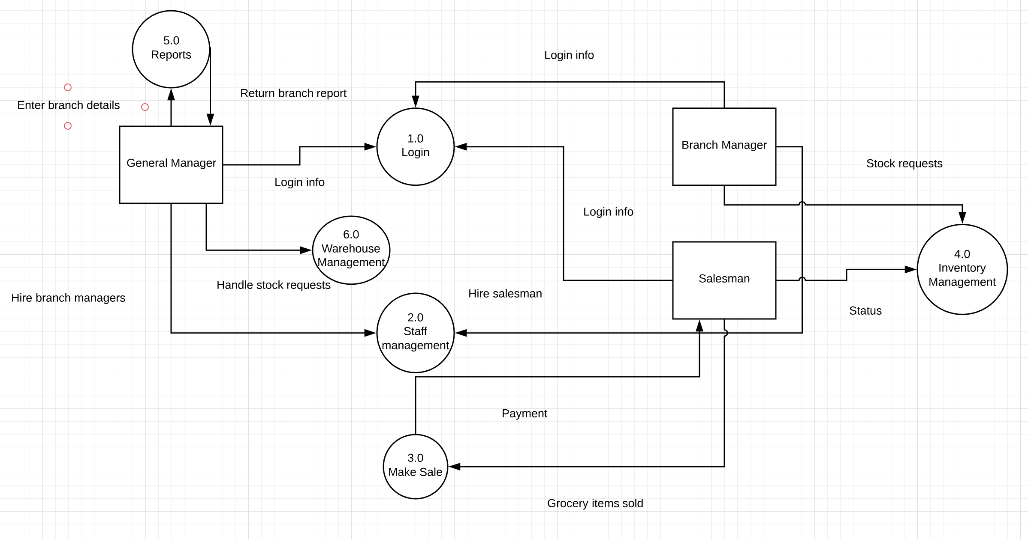
Dataflow Diagram (Level 0)

Appendix C: Design Models

Component Model
